Taping machine for sheets and plates model PTA155x600 el
Motorized semi-automatic Protection tape application machine for steel, aluminium or other sheets, up to 1550 mm wide and 6000 mm long one side at a time.
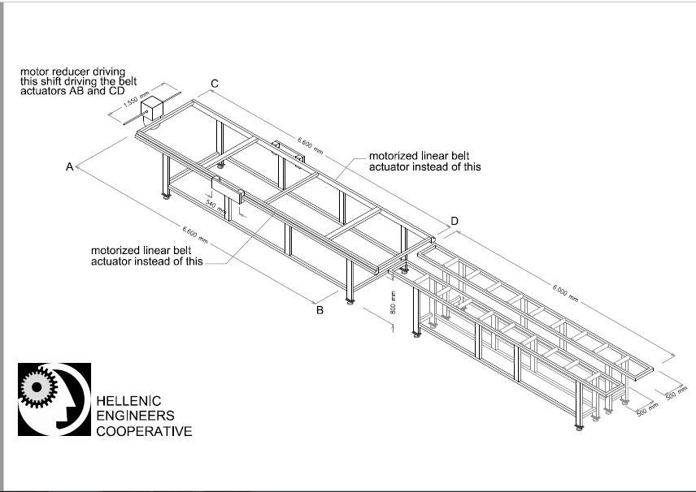
Linear belt actuators are shown schematically on the above sketch as AB and CD.
Each one of the linear actuators in 3d drawing will be as the one below by the manufacturer ITEM: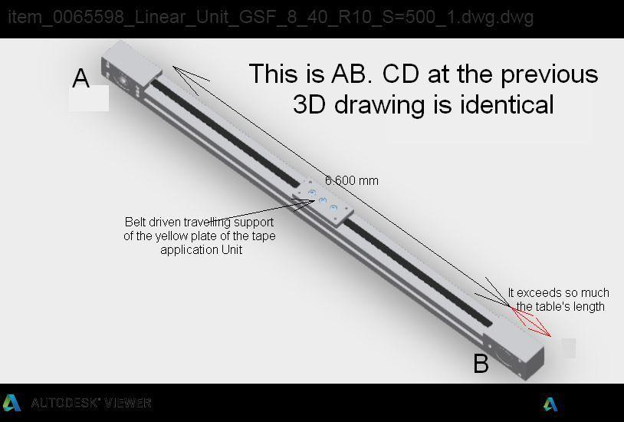

The Tape support and tape application travelling unit is composed by the 2 plates of yellow produced by laser cutting of 10 mm thick steel plates.
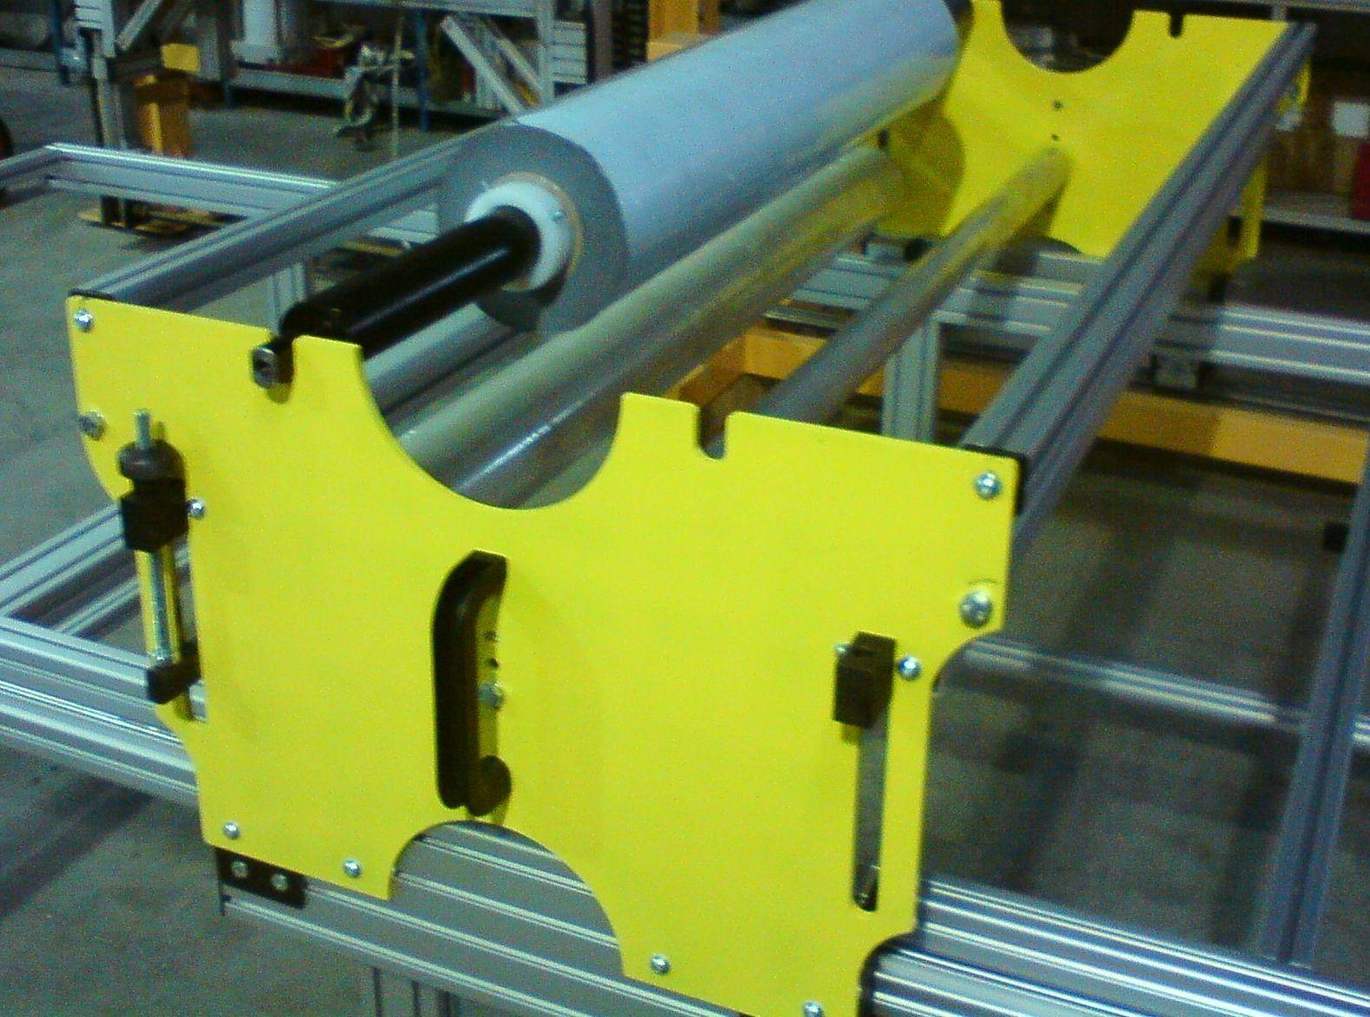
The top view layout including the free roller tables for the loading of the aluminium sheets is as below:
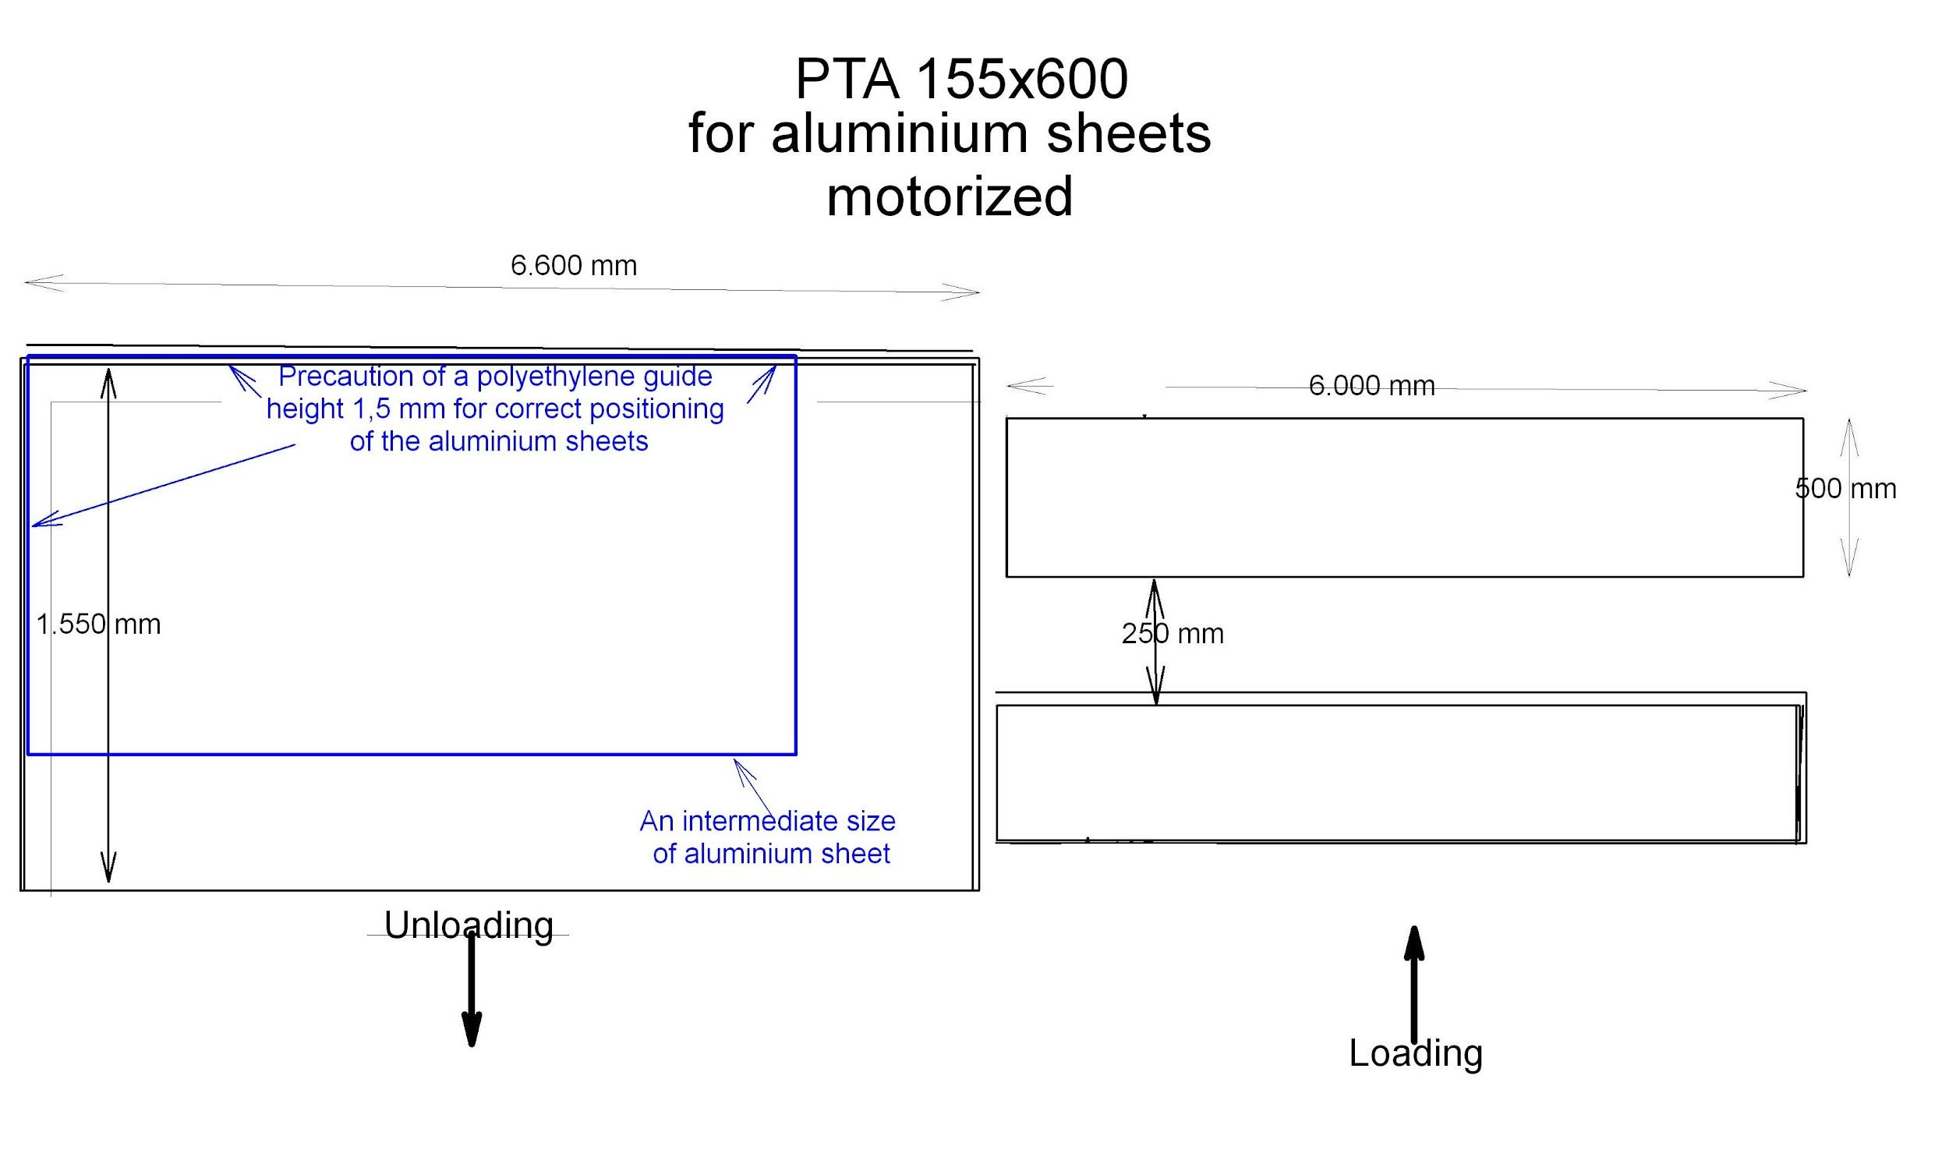

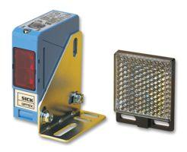
There will also be a precaution of a 2 mm short height polyethylene guide to facilitate the positioning of the loaded aluminium sheets.
A similar facility will be at the left end of the table too at the width of 1.550 mm
The aluminium sheets of various sizes are loaded always in a way that 2 of the 4 sides are guided by the polyethylene strips of the table borders.
The operator selects on the operation panel the length of the sheet to tape.
Then the operator is attaching at the left side of the table(*) the loose adhesive tape which comes hanged from the tape roll as it was cut in the previous taped sheet.
Immediately after he pushes the extra start button placed near this point and the taping starts at p.e. 10 m/min speed. When the taping unit has been moved at the pre-selected distance equal to sheet’s length, the taping unit stops for the operator to cut the tape by the special knife guided by the sheet itself. He then pushes the nearby return button and the taping unit returns at his start point at a preselected high speed of p.e. 20 m/min.
There are 2 return buttons placed at 3.000 mm from the start point and at 5.500 mm near the other end in length of the table.
The taped sheet is unloaded by the operator or his helper or both, depending on the sheet’s size and the cycle restarts for the next sheet to tape.
(*): left, looking to the layout
Our supply includes:
- One tape application table equipped as above and visualized by the 3D drawing above including the tape application unit driven by 2 linear belt actuators motorized
- The electric motor reducer driving the 2 linear belt actuators by a common shaft at exactly the same speed placed at the left end of the main table.
- Two free roller tables 500 mm wide and 6.000 mm long for the loading operation of the sheets
- The electric plant including an operation panel on an electric cubicle including the PLC, 2 inverters and the rest of necessary switches, cabling and various necessary electric parts
- 1 extra start button at the left of the main table and 2 return buttons in intermediate positions as described before.
- 2 emergency alarm stop buttons placed adequately
- I security photocell system made by SICK for avoiding the moving taping unit to hit any people moving around the plant.
- One operation manual describing EN regulations with CE conformity declarations
