EN News
February 2019
Our admission at Mountains Partnership

We have been appointed members of the Mountain Prtnership, an association of FAO organization of UN
Below the text of our acceptance as members

Rome, 20 February 2019
Dear Mr Vamvakousis,
We are very pleased to welcome the Hellenic Engineers Cooperative as a member of the Mountain Partnership. We look forward to working together with the common goal of achieving sustainable mountain development around the world. We encourage the exchange of knowledge, information, expertise and resources among our global membership, and to that end invite you to propose and take part in initiatives that improve the quality of life and sustain healthy environments in the world’s mountain regions. We are confident that the Hellenic Engineers Cooperative will not only benefit from what the Partnership has to offer, but will also contribute significantly to realizing our agreed upon objectives and vision.
Please be reminded that membership is for four years, after which it may be renewed. Your membership will expire in February 2023.
We encourage you to visit the Mountain Partnership website for news, events and information about the activities and members of the Mountain Partnership.
We appreciate the commitment, energy and broad experience that the Hellenic Engineers Cooperative will bring to this international alliance.
Sincerely,
Yuka Makino
Coordinator
Mountain Partnership Secretariat
Mountain Partnership Secretariat - Food and Agriculture Organization (FAO) of the United Nations
Viale delle Terme di Caracalla - 00153 Rome, Italy
Fax: +39 06 5705-5137. E-mail: info@mountainpartnership.org.
Web site: www.mountainpartnership.org
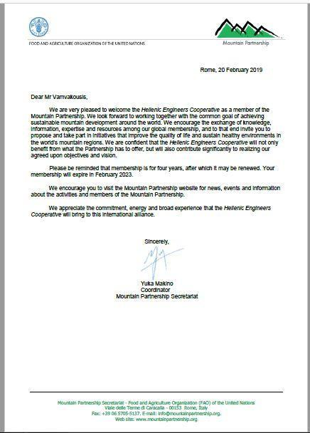

ΕΛ Νέα
Φεβρουάριος 2019

Τμήμα Β' 6ου Τομέα Οικολογία και Ευζήν
Αποδοχή της Σύμπραξης μας Μηχανικών ως μέλους της Εταιρείας Βουνών (Mountain Partnership) του Οργανισμού FAO του ΟΗΕ.

Παρακάτω η επιστολή καλωσορίσματος στην Εταιρεία
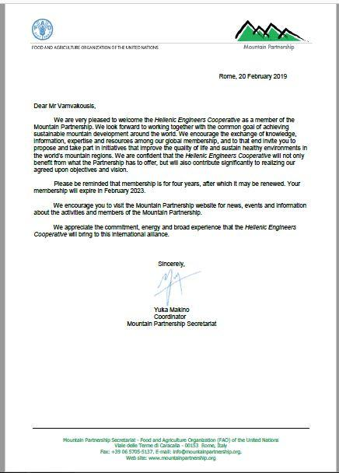
Και ο σχετικός ιστότοπος http://www.fao.org/mountain-partnership/en/

